# portfolio hosing in ec2 public ip using terraform, ansible and Jenkins

1st : make a key pair then,  
make a terraform file for lunching an instance.

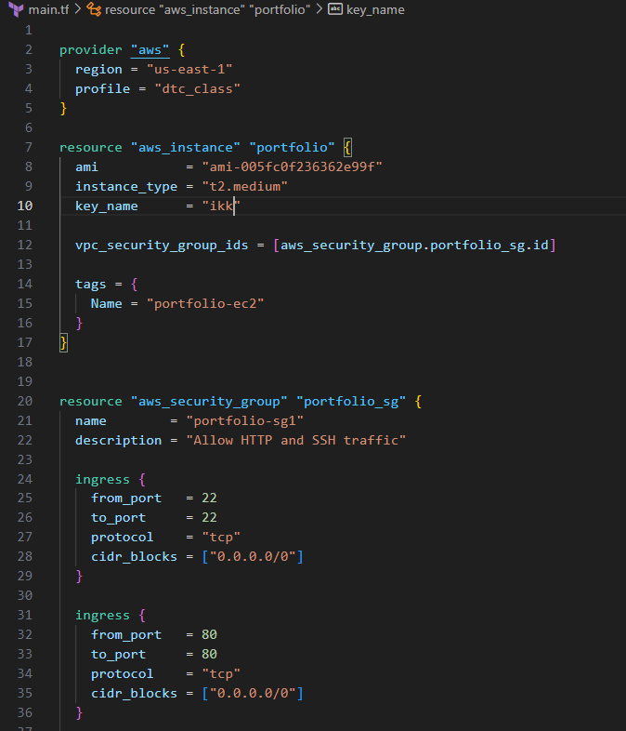

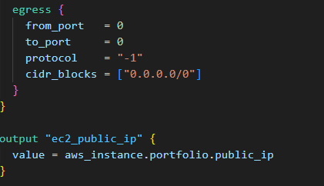

Note: to give access to for aws, add aws credentials SecretKey and AccessKey in the .aws/credentials file.

Run the main.tf file using: terraform init and terraform apply

2nd: ssh into your instance and install ansible,  
clone your git repo,  
make a playbook for installing nginx or apache and copying your portfolio files into the server side.

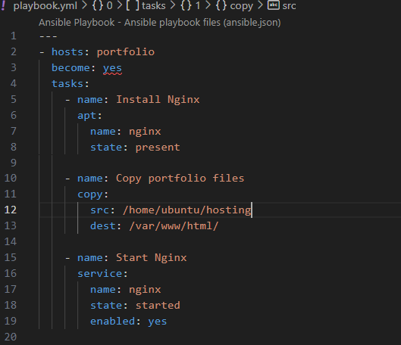

Make an .ini file:



Then run the playbook using : ansible-playbook -i my.ini playbook.yml

3rd: install java using : sudo apt install fontconfig openjdk-17-jre  
install jenkin package using:   
curl -fsSL https://pkg.jenkins.io/debian/jenkins.io-2023.key | sudo tee /usr/share/keyrings/jenkins-keyring.asc > /dev/null  
echo deb [signed-by=/usr/share/keyrings/jenkins-keyring.asc] https://pkg.jenkins.io/debian binary/ | sudo tee /etc/apt/sources.list.d/jenkins.list > /dev/null  
sudo apt update  
sudo apt install Jenkins  
after installation add Jenkins port in the sg i.e 8080  
log in to Jenkins and configure a freestyle project:

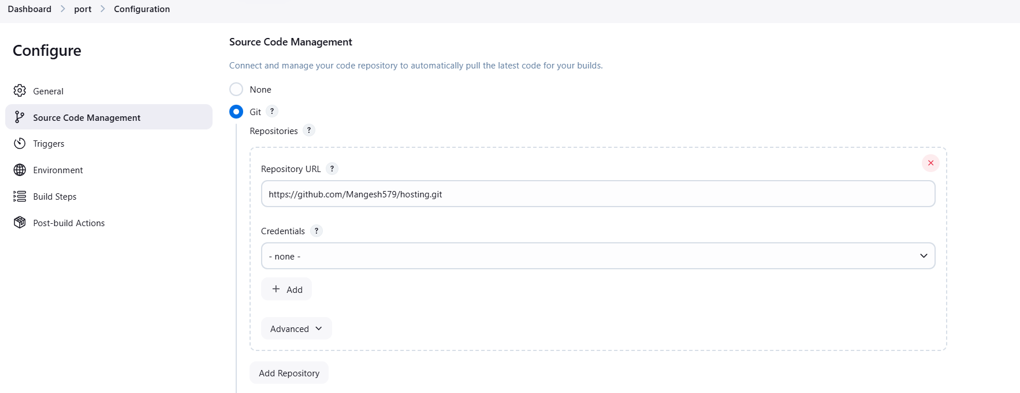

Add credentials:  
in secret text using github’s token  
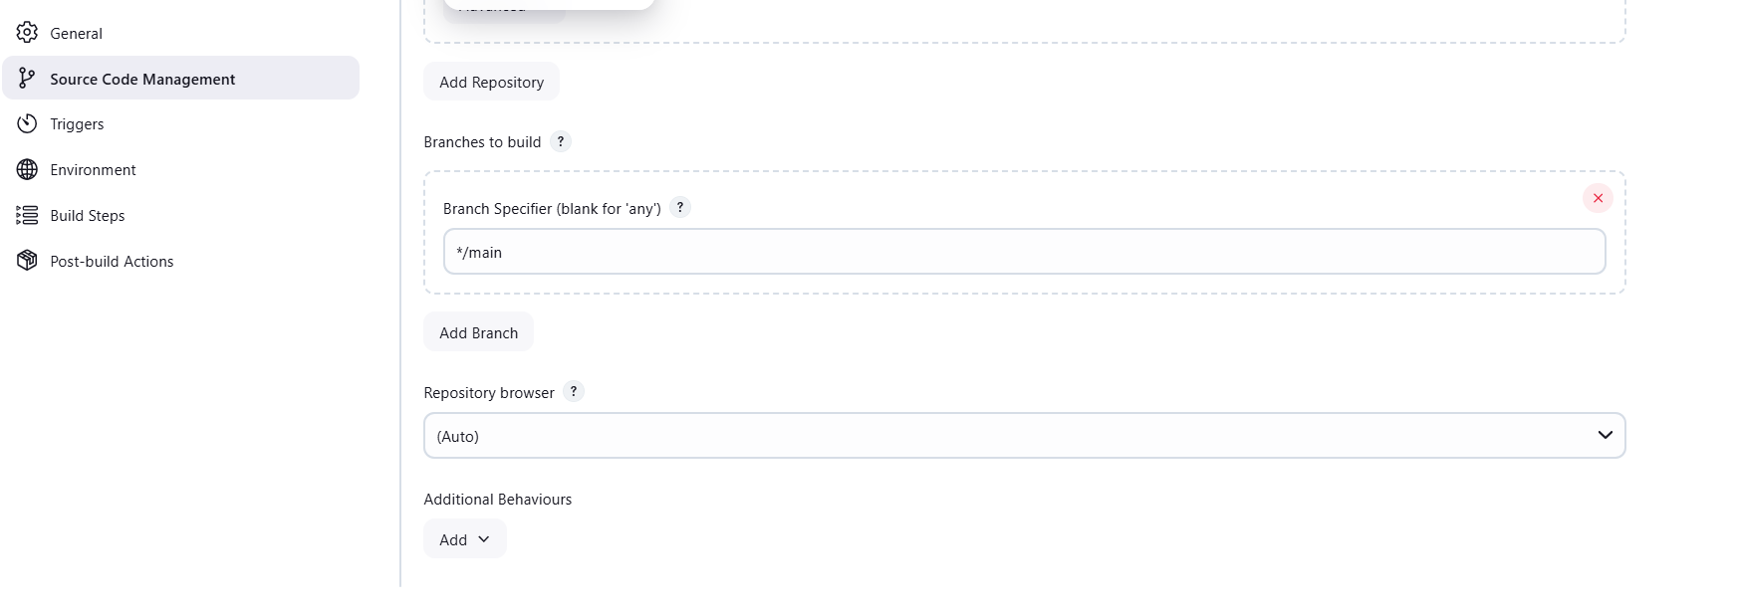

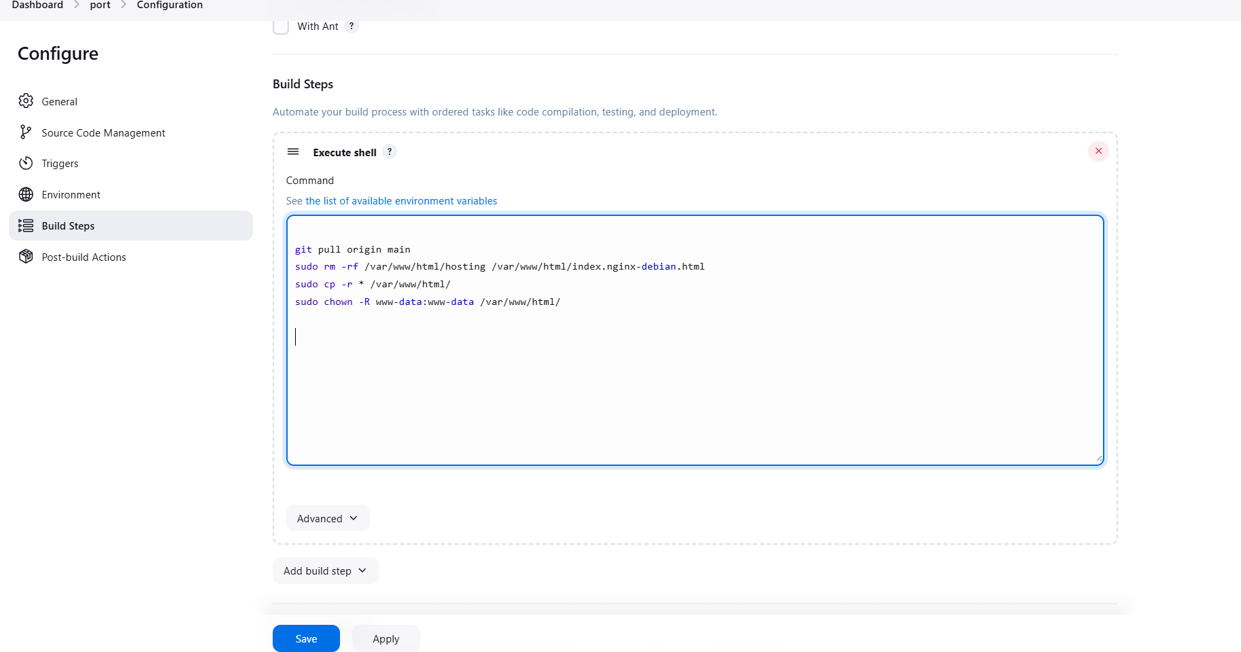

Then save it and build the project.  
to give Jenkins permission to use sudo commands use :

In your instance:  
sudo visudo

Add:  
jenkins ALL=(ALL) NOPASSWD: ALL  
  
Note: configure the path of your index.html file in the /etc/nginx/sites-available/default.

Then open your public ip of your instance in the browser.